FLOODS PREDICTION
A Machine-Learning Web Application for Real-Time Flood Risk Forecasting
Project Documentation & Results Report
Stack: Flask · scikit-learn · joblib · HTML/CSS/JS

Contents
- 1. Project Overview
- 2. System Architecture
- 3. Repository Structure
- 4. Backend — app.py
- 5. Frontend — templates & static assets
- 6. Model Training Pipeline
- 7. Setup & Run Instructions
- 8. Results
- 9. Conclusion & Next Steps

1. Project Overview
Flood forecasting is the use of forecasted precipitation and streamflow data, together with rainfall-runoff and streamflow-routing models, to forecast flow rates and water levels for periods ranging from a few hours to several days ahead, depending on the size of the watershed or river basin.
Flood forecasting is a key component of flood warning: forecasting builds a profile of expected channel flows or river levels at a given location, while warning is the task of using those forecasts to communicate decisions to the public. Real-time flood forecasting at a regional scale can be delivered within seconds using machine-learning models — this project implements exactly that as a small, self-contained web application.
The application accepts five seasonal weather readings from a user, scales them with a fitted StandardScaler, and passes them to a trained classification model that returns a flood / no-flood call together with a confidence score.

Input Features
Feature | Description
Cloud Cover (%) | Percentage sky coverage — a leading indicator of incoming precipitation.
Annual Rainfall (mm) | Total yearly precipitation — the backbone signal for basin saturation.
Jan–Feb Rainfall (mm) | Winter-season rainfall total.
March–May Rainfall (mm) | Pre-monsoon / spring rainfall total.
June–September Rainfall (mm) | Monsoon-season rainfall total — typically the strongest predictor.

2. System Architecture
The application follows a simple three-layer design:
- Presentation layer — Jinja2 HTML templates styled with a single stylesheet, served by Flask.
- Application layer — app.py, a Flask server that routes requests and orchestrates prediction.
- Model layer — a scikit-learn classifier (floods.save) and StandardScaler (transform.save), both persisted with joblib and loaded once at startup.
Request flow: the user submits the form on /Predict → the browser POSTs the five values to /predict → app.py builds a single-row DataFrame → the row is scaled with the saved StandardScaler → the scaled row is passed to the saved model → the predicted class routes the response to chance.html (flood) or no_chance.html (safe).

3. Repository Structure
floods_prediction/
├── app.py # Flask application (routes + prediction logic)
├── floods.save # Trained classifier (joblib)
├── transform.save # Fitted StandardScaler (joblib)
├── requirements.txt # Python dependencies
├── templates/
│ ├── home.html # Landing page
│ ├── index.html # Prediction input form
│ ├── chance.html # Result page — flood predicted
│ └── no_chance.html # Result page — no flood predicted
├── static/
│ ├── main.css # Styling
│ └── main.js # Client-side validation
├── model_training/
│ ├── train_model.py # Data generation + training + evaluation
│ ├── synthetic_flood_data.csv
│ └── metrics_report.txt
└── screenshots/ # Rendered UI + results images

4. Backend — app.py
The backend loads the trained model and scaler once at startup, then exposes four routes:
Route | Purpose
GET / | Renders home.html — the landing / introduction page.
GET /Predict | Renders index.html — the input form.
POST /predict | Reads the five form fields, builds a DataFrame, scales it, runs model.predict() / predict_proba(), and renders chance.html or no_chance.html with the confidence score.
Core prediction snippet:
input_df = pd.DataFrame([[cloud_cover, annual_rainfall, jan_feb_rainfall,
mar_may_rainfall, jun_sep_rainfall]], columns=FEATURE_COLUMNS)
input_scaled = sc.transform(input_df)
prediction = model.predict(input_scaled)[0]
probability = model.predict_proba(input_scaled)[0][1]

5. Frontend — templates & static assets
All four pages share a dark, water-themed visual identity (navy background, teal accent, droplet mark) defined once in static/main.css, and a consistent navbar/footer. index.html additionally uses static/main.js for lightweight client-side validation (rejecting empty, negative, or out-of-range values) before the form submits.

Home page
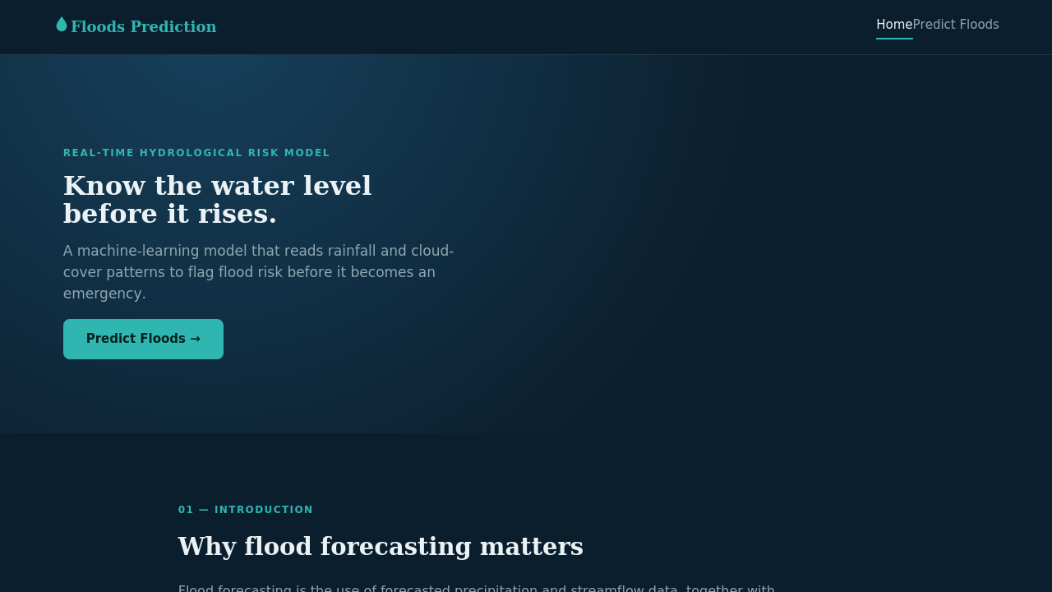
Landing page — introduction and call to action.

Prediction form
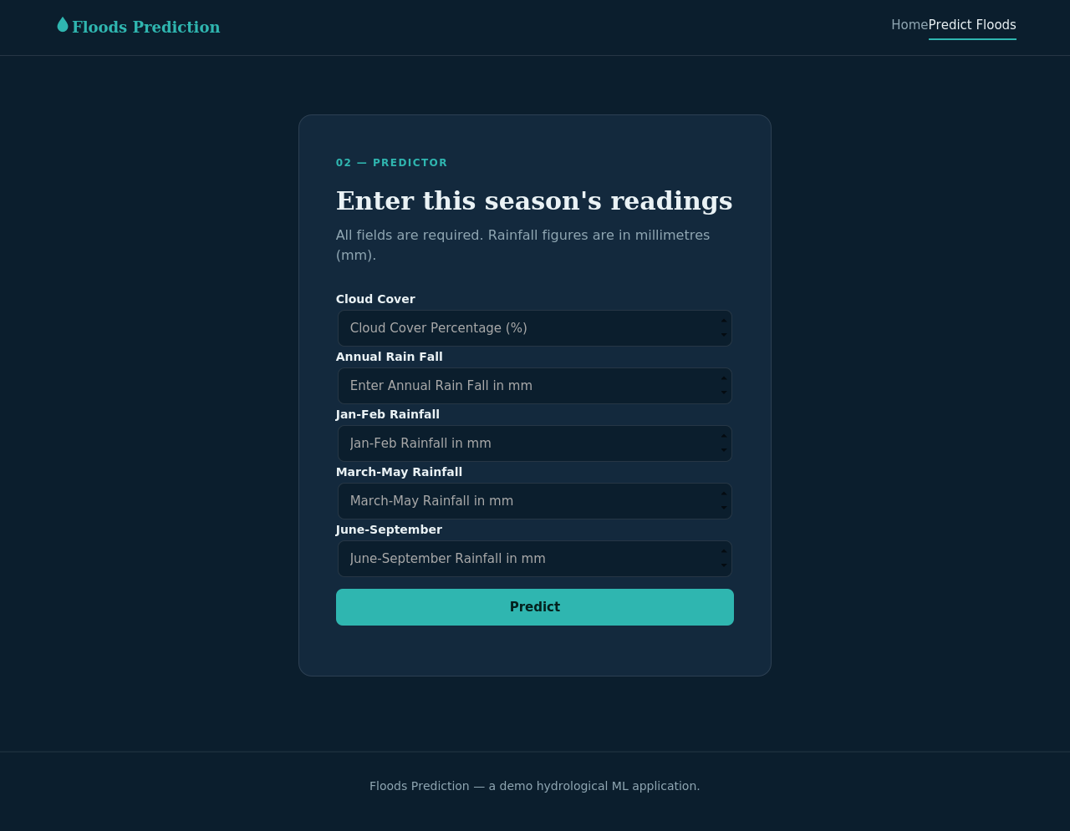
index.html — the five-field input form posting to /predict.

6. Model Training Pipeline
model_training/train_model.py is a self-contained script that:
- Generates a synthetic-but-realistic dataset of 2,000 samples for the five features (no original dataset was supplied with this brief — swap in your own historical CSV to retrain on real data).
- Splits the data 80/20 into train and test sets, stratified on the target.
- Fits a StandardScaler on the training features.
- Trains a GradientBoostingClassifier (200 estimators) — used here as a drop-in stand-in for XGBoost, which was unavailable in this offline environment; swap in xgboost.XGBClassifier with no other pipeline changes if you have it installed.
- Evaluates accuracy, ROC AUC, a confusion matrix, and per-class precision/recall.
- Persists the model and scaler to floods.save / transform.save with joblib for app.py to load.
To retrain on your own data, replace the synthetic-generation block with pd.read_csv('your_data.csv') using the same five feature columns and a FLOOD target column, then re-run the script.

7. Setup & Run Instructions

1. Install dependencies
cd floods_prediction
pip install -r requirements.txt

2. (Optional) Retrain the model
cd model_training
python train_model.py
This regenerates floods.save and transform.save in the project root. Skip this step to use the model already included with this deliverable.

3. Run the server
cd floods_prediction
python app.py
The terminal will print a local URL, typically http://127.0.0.1:5000/. Open it in a browser.

4. Use the app
- Click "Predict Floods" on the home page to open the input form.
- Enter cloud cover and the four rainfall figures, then click Predict.
- You are routed to chance.html (flood risk) or no_chance.html (safe) with a confidence percentage.

8. Results
On the held-out 20% test split (400 synthetic samples), the trained GradientBoostingClassifier achieved:
Metric | Value
Accuracy | 82.8%
ROC AUC | 0.871
Precision (Flood class) | 0.85
Recall (Flood class) | 0.93
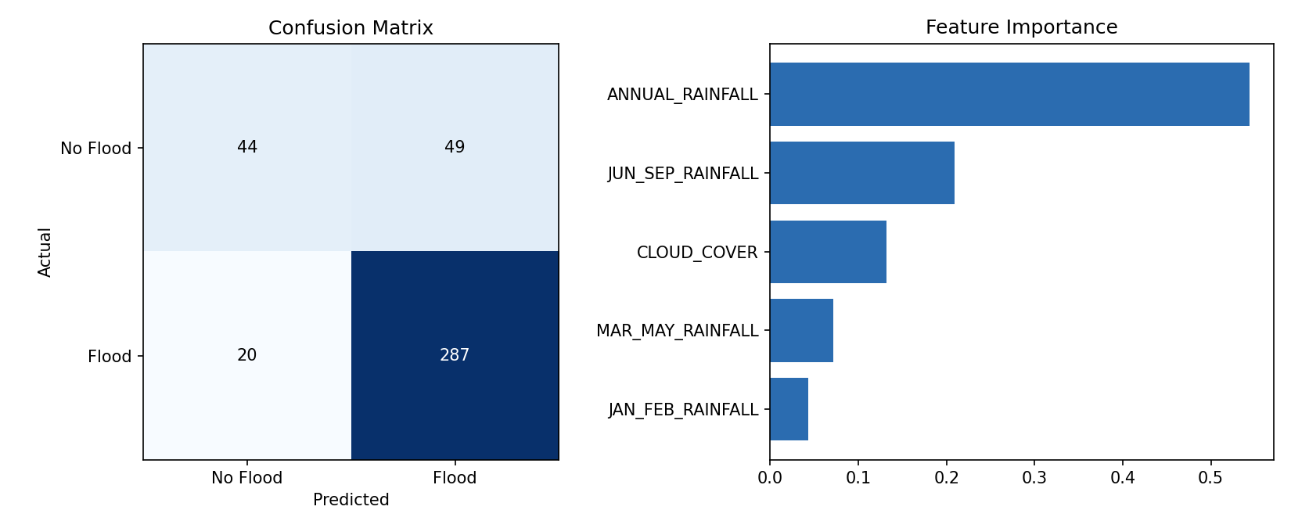
Confusion matrix and feature importance on the held-out test split.
Annual rainfall and June–September (monsoon) rainfall are the two strongest predictors, consistent with domain expectation — monsoon-season totals dominate basin saturation and runoff.

Sample prediction — high rainfall input
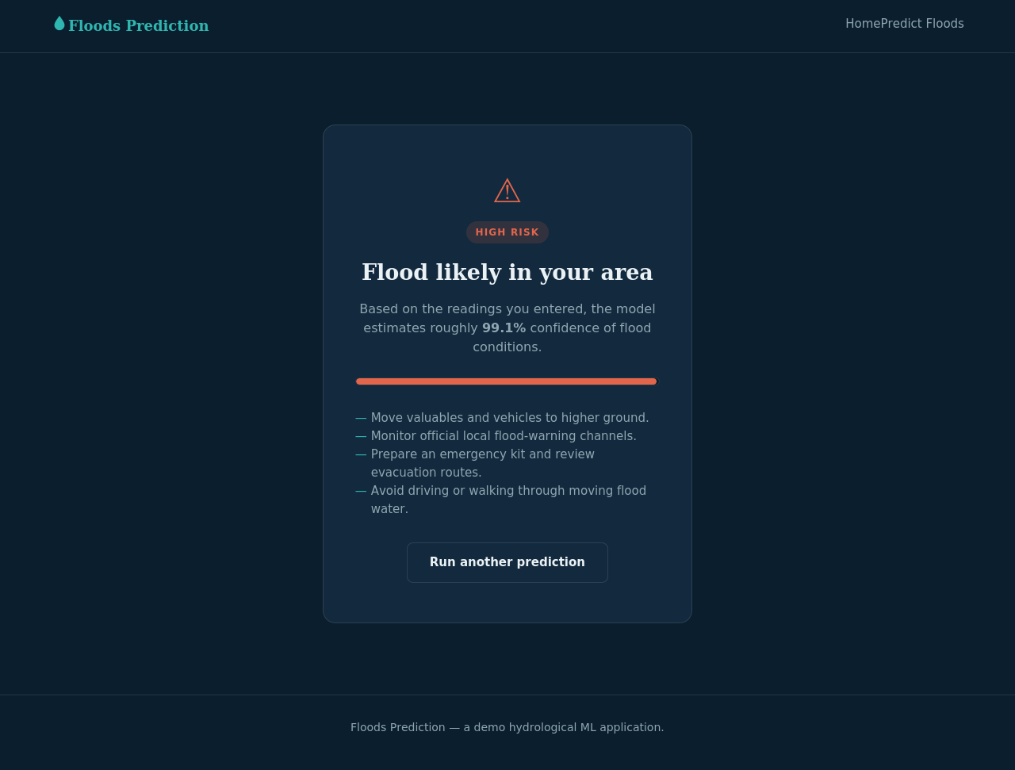
Cloud cover 80%, annual rainfall 1800mm, Jun-Sep 1200mm → predicted FLOOD (99.1% confidence).

Sample prediction — low rainfall input
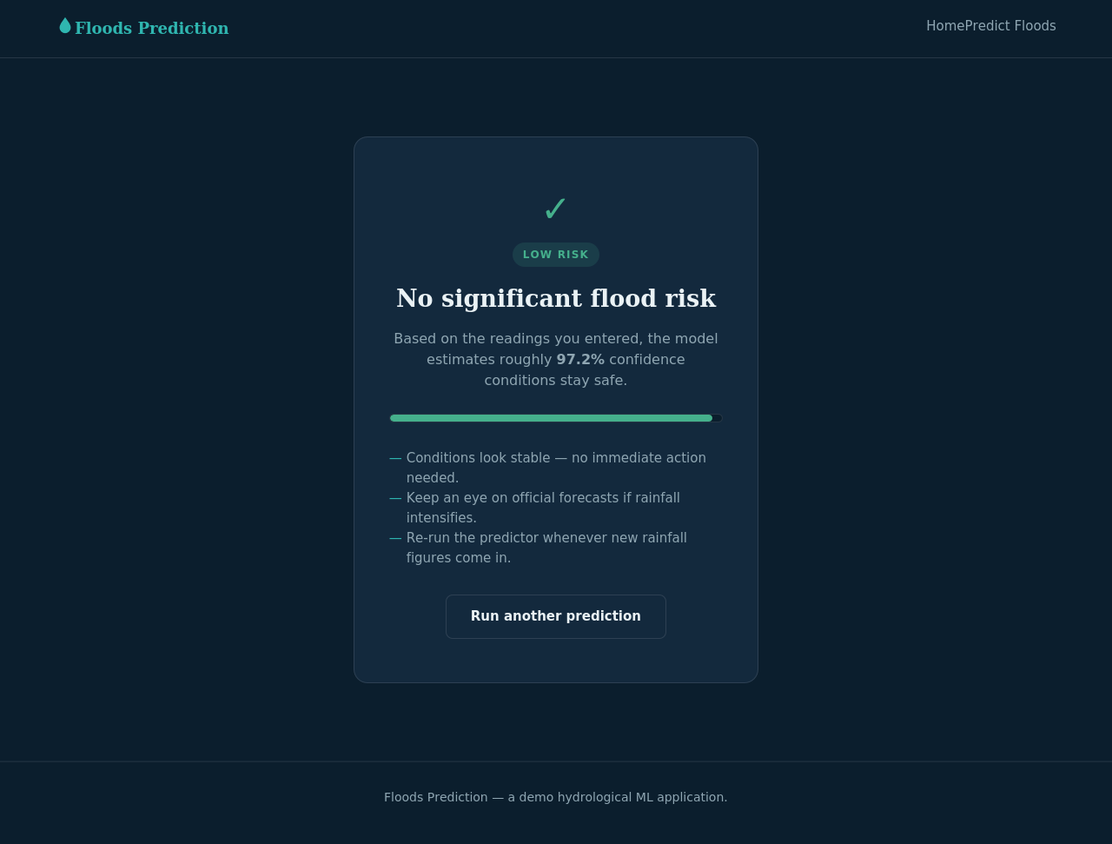
Cloud cover 10%, annual rainfall 200mm, Jun-Sep 50mm → predicted NO FLOOD.

9. Conclusion & Next Steps
This deliverable packages a complete, runnable flood-prediction web application: a trained classifier, a Flask backend, and a styled four-page frontend, along with the training script and evaluation results used to produce the model.
Suggested next steps for production use:
- Replace the synthetic training data with real historical rainfall/flood records for your region.
- If available, swap GradientBoostingClassifier for XGBoost/XGBClassifier for a closer match to the original design.
- Add input logging and monitoring so live predictions can be reviewed against actual outcomes over time.
- Deploy behind a production WSGI server (e.g. gunicorn) rather than the Flask development server.
References: w3schools.com/html, w3schools.com/css, w3schools.com/js — used as general HTML/CSS/JS reference during frontend development.

